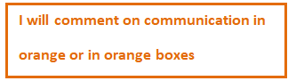

TMA 01 abs247 Student Name Aaron Smith.

personal identifier: B2769278.



Question 1

(a) (i) Factor Tree for 3780

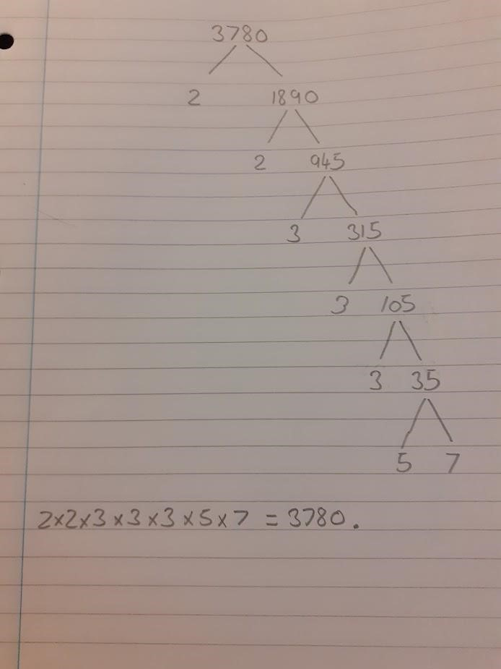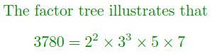

Please try to use power

notation. It is neater.



Question 1

(a) (i) Blank Page for Comments.

(ii) Calculate

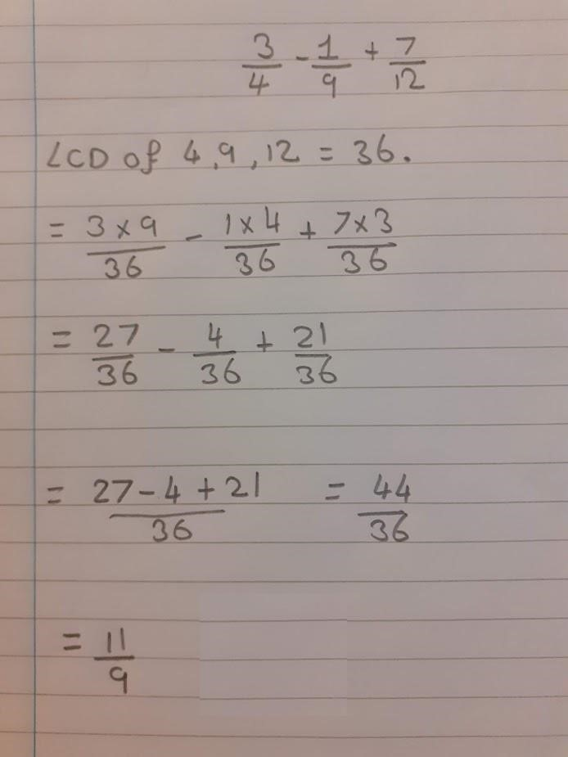

Equals signs are for linking two equal quantities or expressions.

What is on the left of this equals sign? You have misused it.

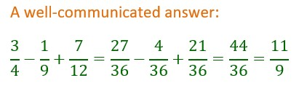

1. Blank Page for Comments.

1. Simplify the surd

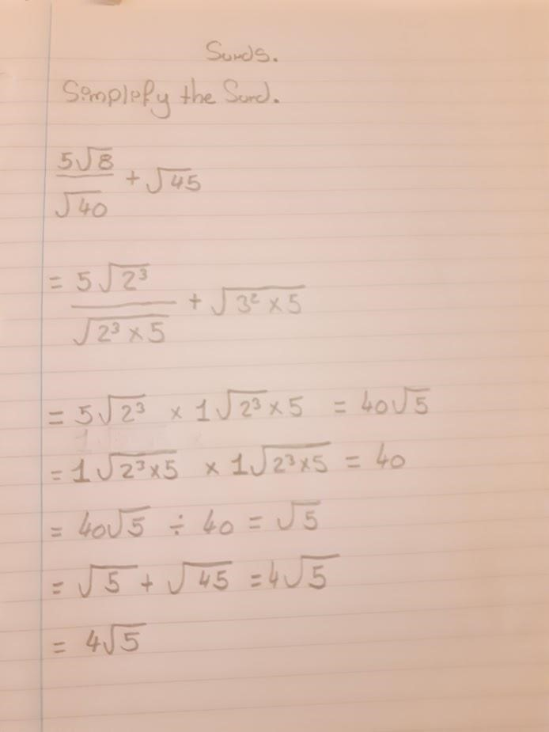

This is not equal to the

last thing you wrote on

the line above, so

you've misused the

equals sign.

This is not equal to the

last thing you wrote on

the line above

This is not equal to the

last thing you wrote on

the line above

And this is not equal to

the last thing you wrote

on the line above



You answer is correct, but I'm not sure how you got there. I

think you might be multiplying the numerator and denominator

of the fraction by the denominator, but that isn't how you've

written the calculation and you've said that all of these lines

are equal to each other, which they are not. (-1 mark for

unclear method)

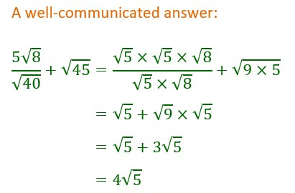

(iii) Blank Page for Comments.

(b)

(

i)

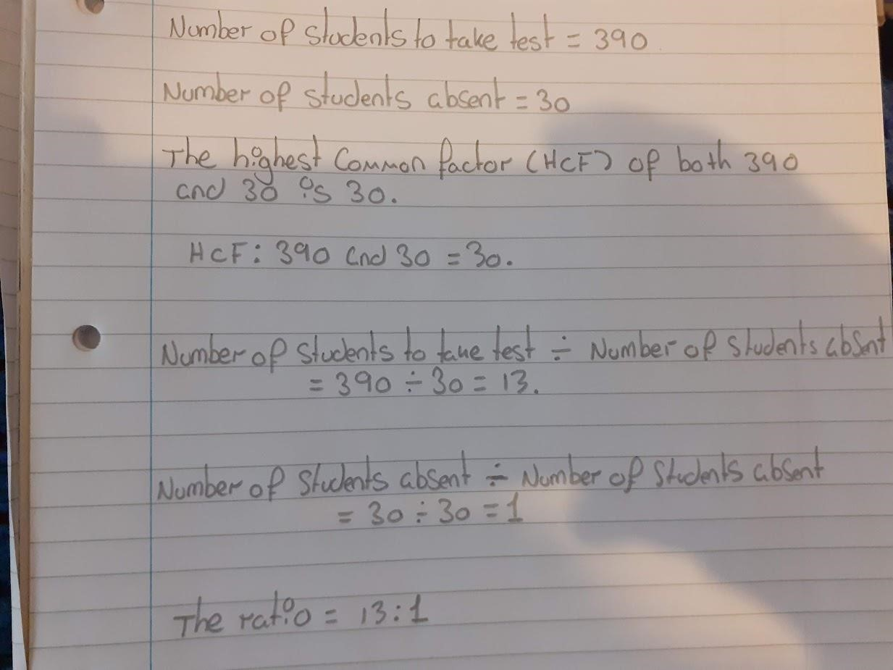

-1

mark for omitting this

is



(b) (i) Blank Page for Comments.

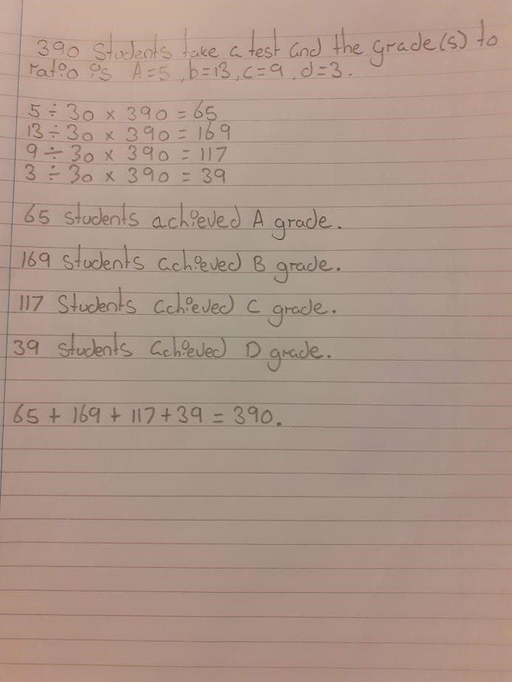

First, you need to explain where you got 30 from.

mark

).

(-1

:

:

:

These are all unexplained sums. You must start every

calculation with WHAT you are finding a value for.



Again, this is just an unexplained

sum. You were asked to

***explain***

how you could check that your

answers are plausible. This is not

an explanation. (-1 mark)

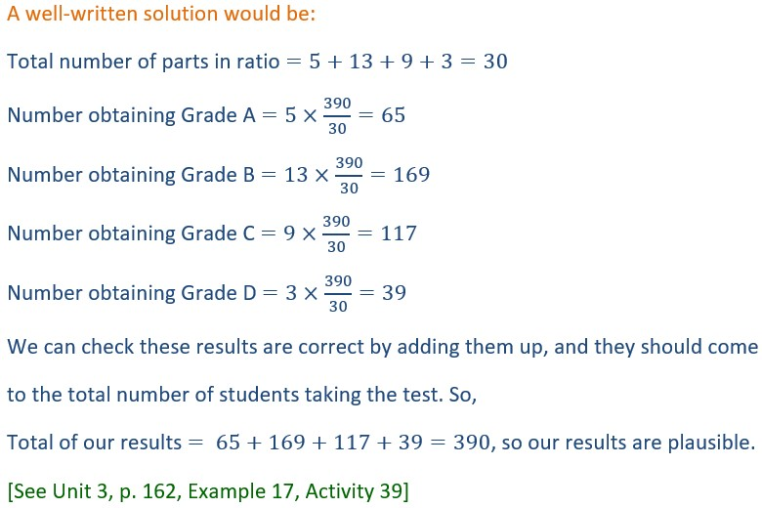

(ii)

(ii) Blank Page for comments.

(c)

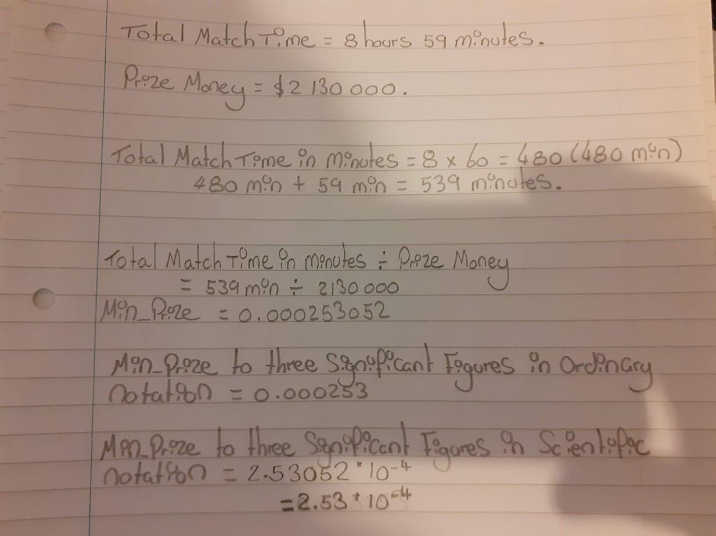

But this is NOT the

total match time. This is

the number of minutes

in 8 hours.

THIS is the total

match time.

Number of minutes in 8 hours =

Total match time =

Time played for

each dollar =

...

This is not an exact

number. This is just the

number of digits your

calculator can display.

You need '...'

What is "min_prize"?

This is not a computing

module. Explain what

this is in words.

minutes (to 3 s.f.)

Why is this so small? I can't see what symbol

you have used. It should be the same size as

your previous characters and should be a

multiplication sign

minutes (to 3 s.f.)

Look over this answer carefully.

Where have you mentioned what

this represents? What about

Naomi Osaka? Where is she

mentioned?



(i)

|  |
| --- |
| This is good, but your communication needs a bit of attention.  This is a practical problem, so must be written in the context of the problem you are solving. Try reading it without looking at the question paper.  You must start every calculation with WHAT you are finding a value for (and make sure that it really is what you are finding a value for).  If decimal digits fill your calculator display then it is likely that the calculator has rounded the number to fit the display. Assume this is the case and finish with '...'.  Do not write abbreviations or variable names that you might use if you were programming. Write in English sentences. If you do use variable names, you must define them first (so it is a bit pointless in this case).  The accuracy of rounded numbers must be stated in brackets AFTER the number.  Don't forget the units of measurement in your final answer. Write a conclusion!  See next page for well-written answer. |

(c) (i) Blank Page for Comments.

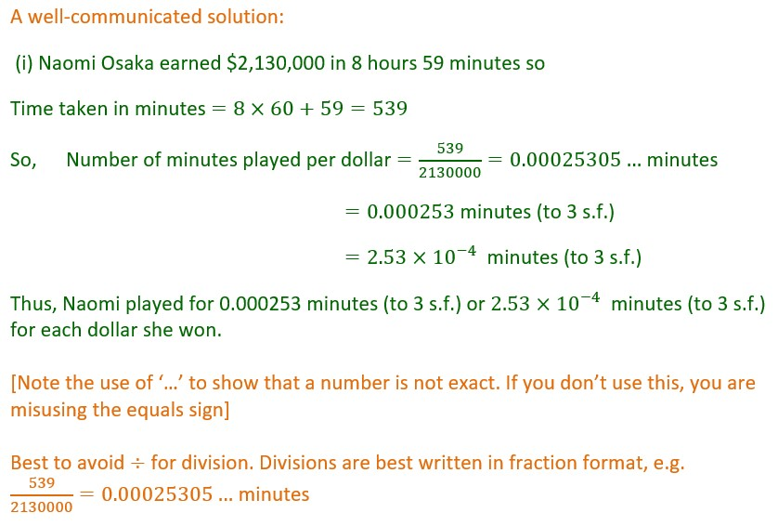

(ii)

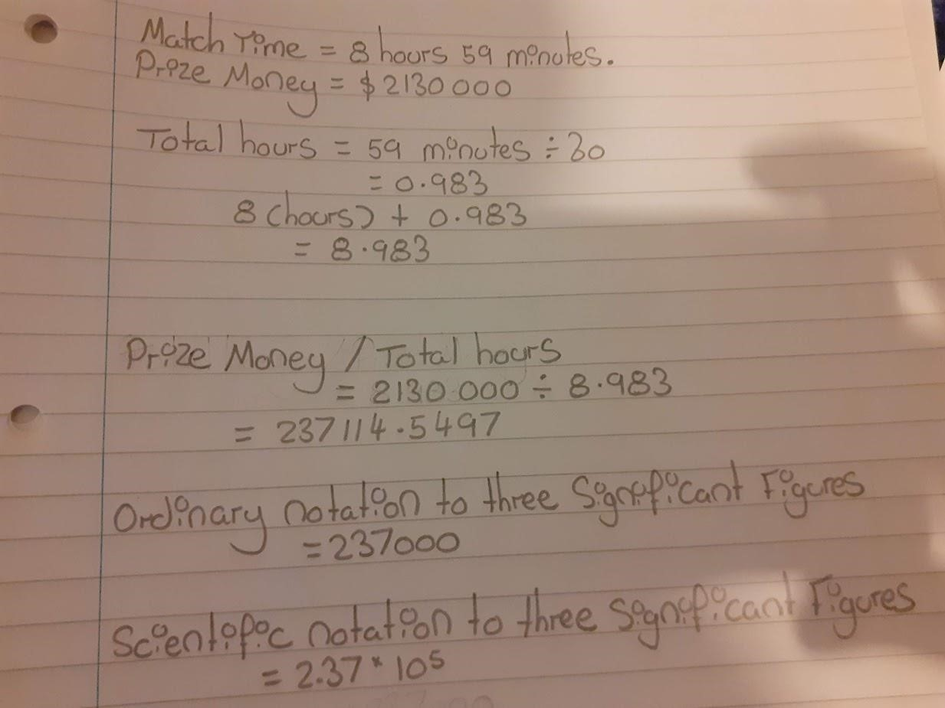

This isn't the total number of hours

played, and you have stopped writing

digits after 3 d.p., so you have

misused the equals sign.

Total time played =

...

...

Do not use "/" for division

Amount earned

per hour =

...

...

This is not correct. You

have incurred a

rounding error by using

a rounded value in the

calculation.

(

to 3 s.f.

)

$

So, WHAT does this

value represent?

$

And what does this

number represent?



-1

mark for using a rounded value

in the calculation.

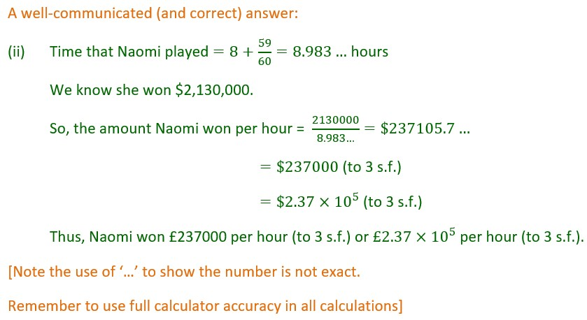

(ii) Blank Page for Comments.

Question 2

(a) (i)

(ii)

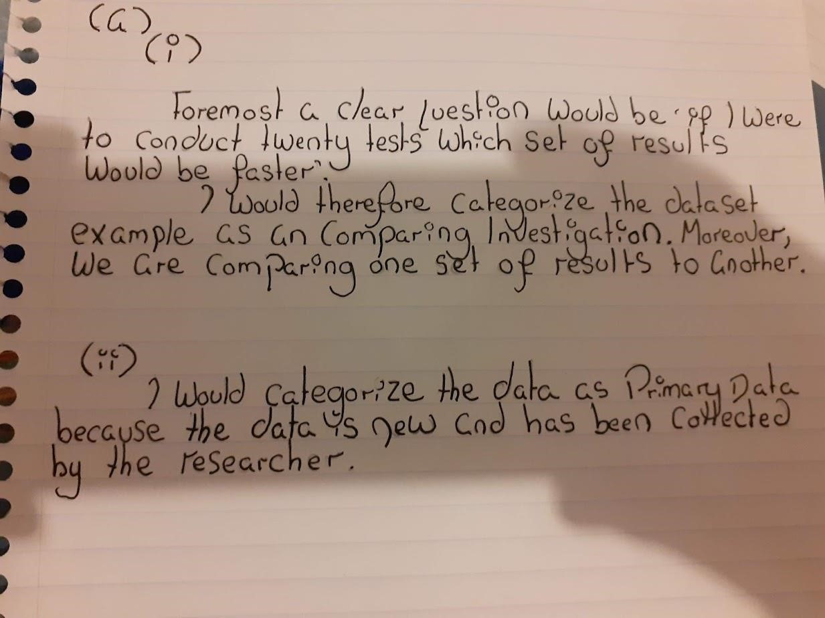

(a) (i) (ii)

Blank Page for Comments.

(b)

(i)

The three features I would be looking for when scanning a dataset is:

* + Missing Data:

This could be values within the dataset (NAN).

Outliers

* + Presence of Outliners:

This would be a value within the dataset that shows an abnormity in size (too large or small). abnormality

?



* + Spurious Precision:

This would be data (usually formatted data) which is different from other values in the dataset.

1. (i) Blank Page for Comments. (b)

(ii)

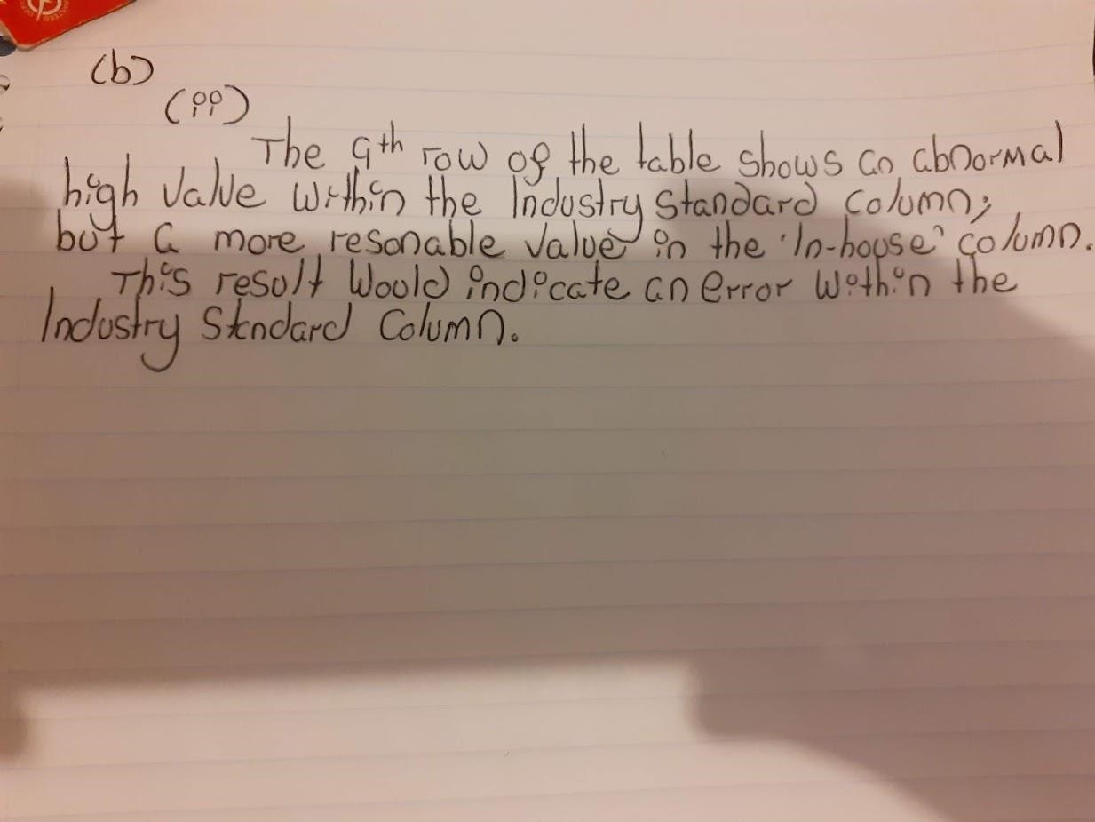

I agree that 648 minutes does seem rather high.

What about the minimum value of the Industry Standard dataset? Is that reasonable?

And what about the maximum and minimum values of the InHouse dataset? Are they

reasonable? (-2 marks)



(b) (ii) Blank Page for comments.

(c)

|  |  |  |
| --- | --- | --- |
|  | Number of minutes to complete the test |  |
|  | Industry standard | In-house |
| Minimum (Min) | 296 | 303 |
| Lower quartile (Q1) | 338.5 | 319.5 |
| Median | 364.5 | |  | | --- | | Careful! |  |  | | --- | | 328.5 |   338.5 |
| Upper quartile (Q3) | 381.5 | 338.5 |
| Maximum (Max) | 648 | 347 |
| Mean | 370.1 | 328.45 |
| Standard deviation | 69.8 | 12 |
| Interquartile range (IQR) | 43 | 19 |
| Range | 352 | 44 |
| Size of dataset (n) | 20 | 20 |



1. Blank Page for Comments. (d) (i) (ii)

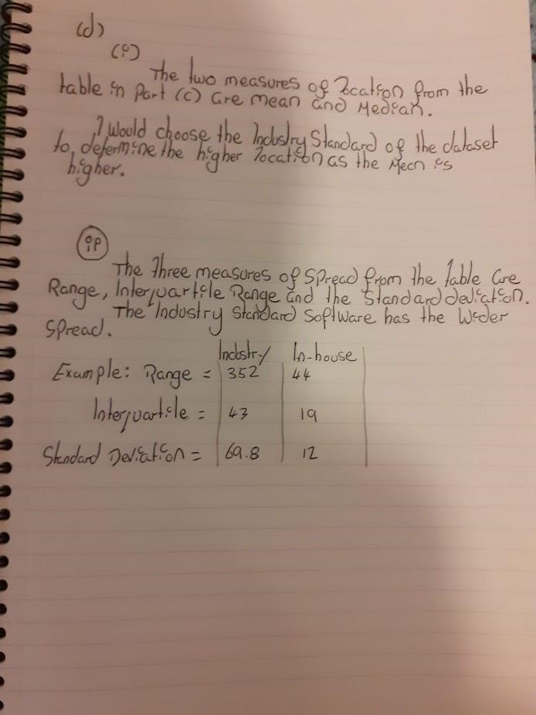

It is not a matter of choice. The Industry Standard dataset has

both a higher mean AND a higher median than the Inhouse

dataset. Therefore, the Industry Standard dataset has the higher

location. (-1 mark)



Just listing the values is not an

explanation. You already wrote

down the values in part (c). Now

you need to compare them.

I agree that the Industry Standard

dataset has a wider spread, but

you need to explain that this is

because all three measures of

spread are greater for the

Industry Standard dataset than

they are for the Inhouse dataset.

(-1

)

mark



1. (i) (ii) Blank Page for comments. (e) (i)

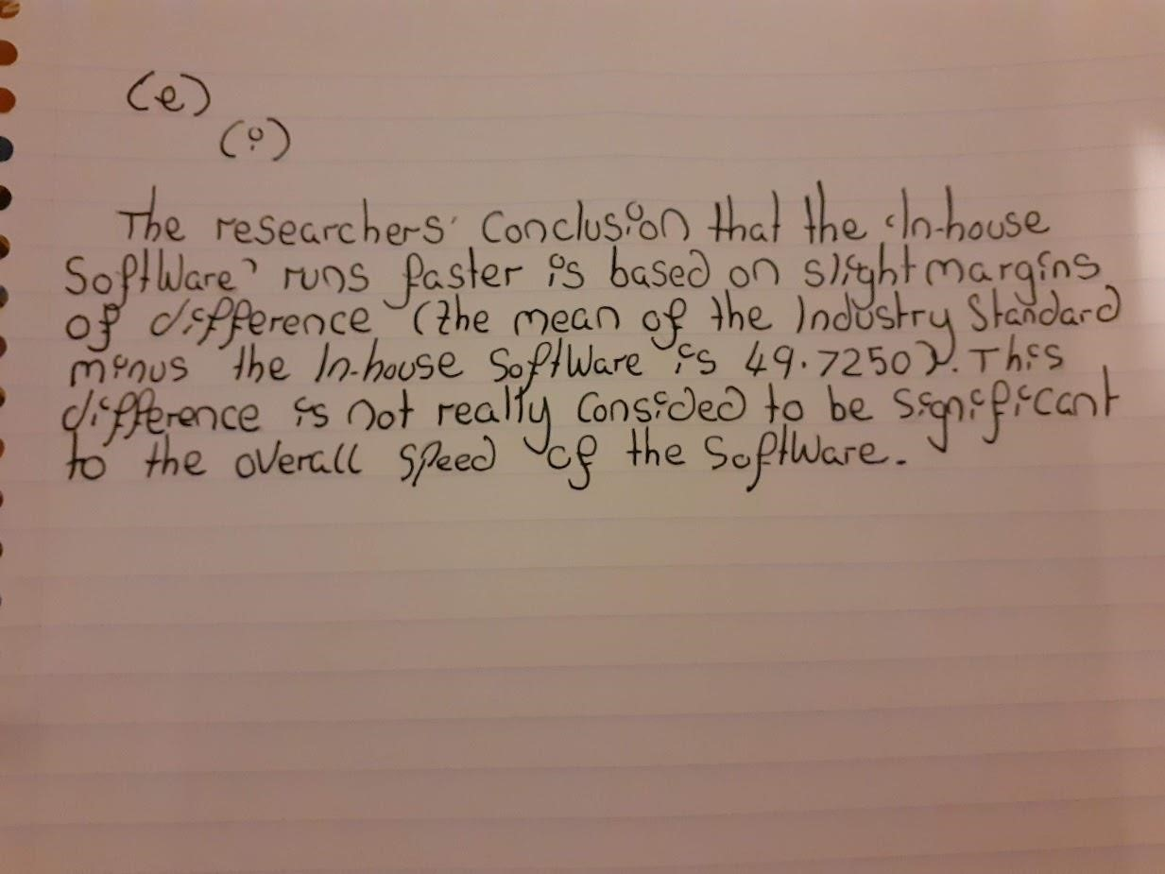

You haven't actually said if you think that the conclusion is reasonable or not, which is

what you were asked.

Actually, this is a reasonable conclusion. Both measures of location are higher for the

Industry Standard data than for the Inhouse data, so this would support the researcher's

conclusion.

[

248]

See Unit 4, p.236, Activity 22 and p.



1. (i) Blank Page for Comments. (ii)

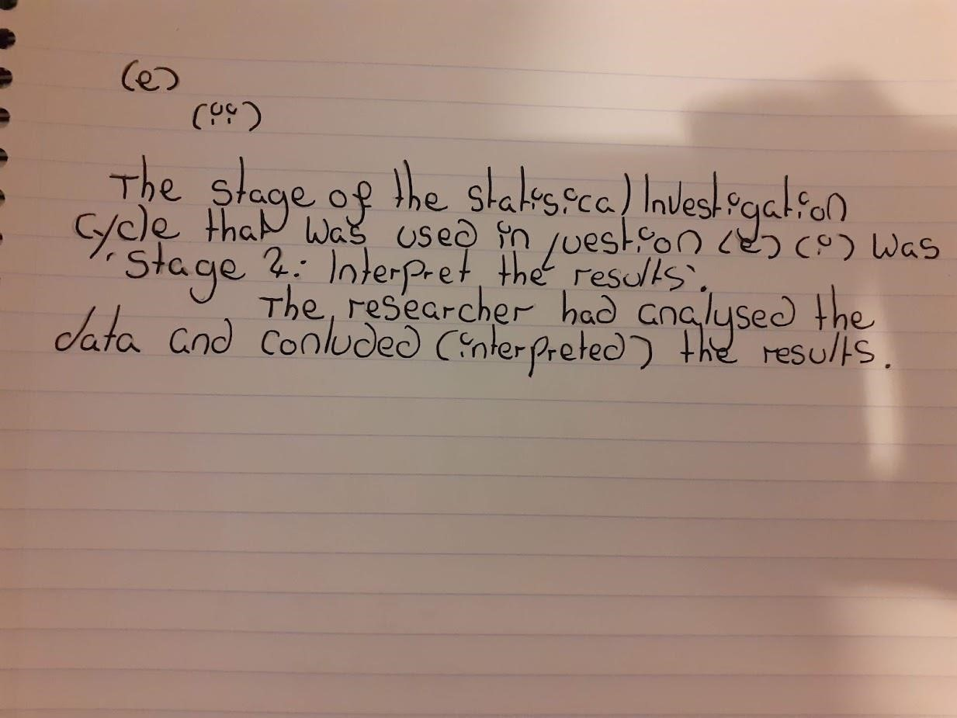

(ii) Blank Page for Comments. (f)

# outlier

|  |
| --- |
| You are right that the mean will be much larger with the outlier included, but this is because the outlier is significantly larger than the correct value, and not because it is smaller. The reason for this is that the mean is calculated by adding all the values and then dividing by the number of values. Adding in a very large number will increase the sum and, therefore, increase the mean.  The median is slightly increased by including the outlier. This is because the outlier is above the median value and the correct value is below the median value.  [Unit 4, p. 236 - 237] |

An outliner in a dataset will have an influence on the mean (less so the median), the mean will increase in value because the outliner was smaller than the original value. If the value is amended the median will increase only slightly but the mean will increase by more.

1. Blank for comments.

What do you mean

1. by 'outcome'?

|  |
| --- |
| But what about the conclusion? Would that be the same? You need to point out that the measures of location are still higher for the Industry Standard data, which means that the researcher would still draw the same conclusion. |

If the corrected mean and median results were to be implemented into the new dataset the outcome would only be slightly more increased. I would not foresee any real changes in results.

(g) Blank for Comments.



Question 3

(i)

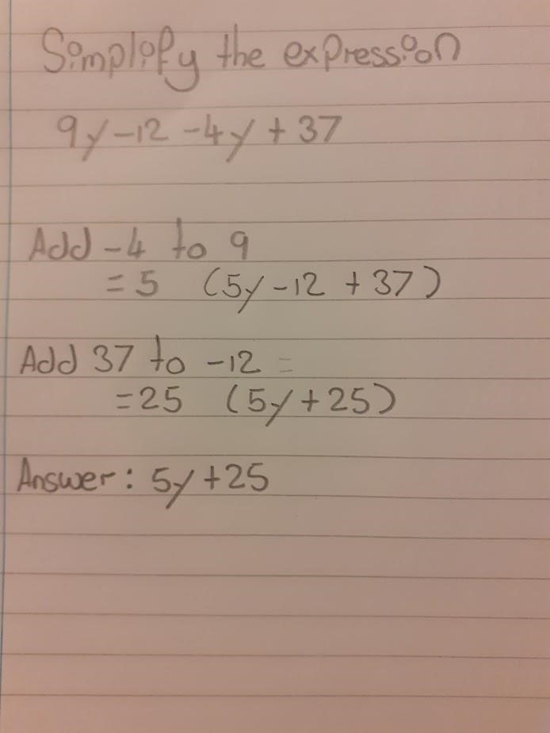

1. Blank Page for Comments.

Question 3

(ii)

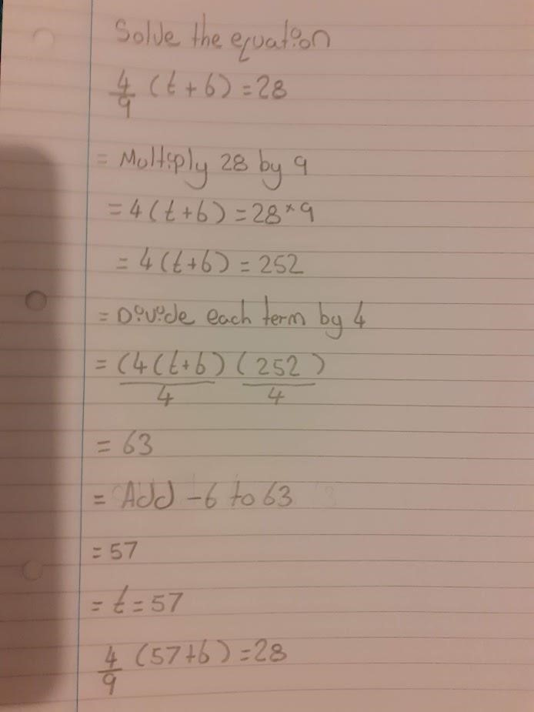

1. Blank Page for Comments.

**Question 3**

(a)

(i)

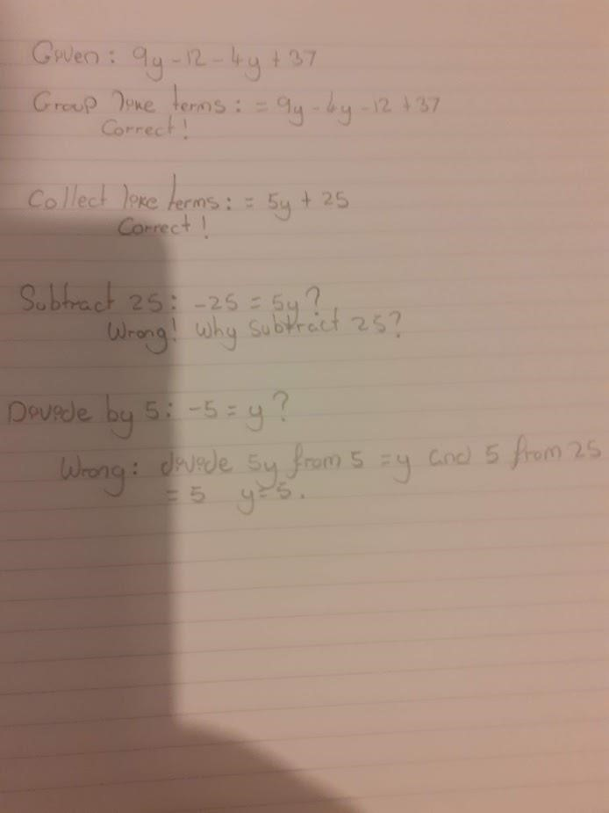

Misuse of equals sign

though. What is on

the left of it?

Not sure what you are

telling me here

More importantly,

what are they

subtracting 25 from?

I think you spotted that there was a problem on the 4th line, but you haven't explained

what that problem was.

On line 4, the student has converted the expression to an equation. They have

actually equated the expression to 0 and then subtracted 25 from both sides of the

resulting equation. They have then gone on to solve their equation.

The student should have been aware of the difference between an expression and an

equation. An expression is a collection of terms linked with operators. An equation is

two expressions linked with an equals sign. You can't solve an expression.

So, the student's working is fine up to line 3 (although they have mistakenly included

equals signs). But they should have stopped there.

(a) (i) Blank Page for Comments.

(a)

(ii)

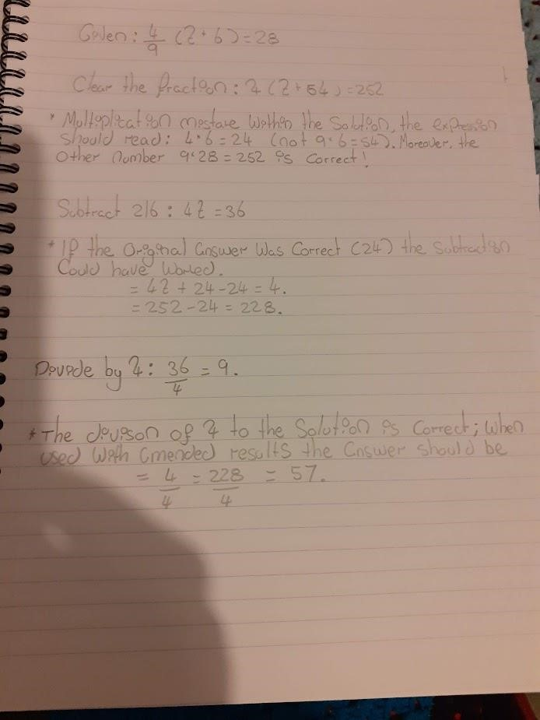

The mistake was when the student (correctly) multiplied both sides by 9 to

clear the fraction. This is a valid operation. However, the mistake was in also

multiplying the 6 in the brackets by 9. The brackets should have remained the

same to give 4(t + 6) = 252.

Other than that, the working is correct.

1

mark for spotting the first error.



(a) (ii) Blank Page for Comments.

(b)

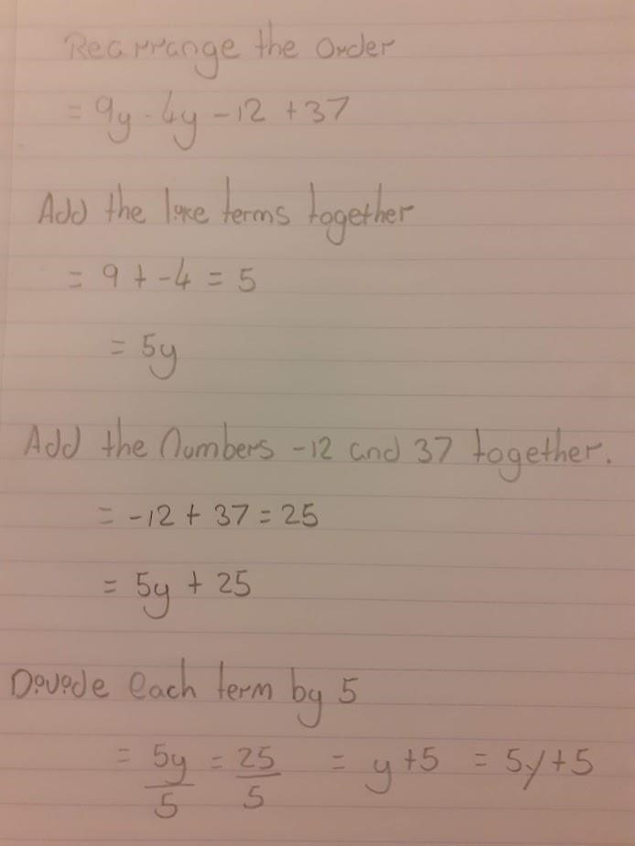

misuse of equals sign

Your result is correct, but the

communication is not good and

some of your working is incorrect.

You should not split the

expression up to deal with parts

separately. Also, you need to be

careful with the equals sign.

Equals signs are for linking two

equal expressions or quantities,

even if they are on separate lines.

So, you can't start a train of

working with an equals sign and

you must make sure that

expressions either side of an

equals sign really are equal.

This equals sign is saying that this expression is equal to

the last thing you wrote on the line above. But this

expression is NOT equal to 25

But y + 5 cannot be

equal to 5y + 5

These two

expressions are not

equal to each other,

and I'm not sure why

you are dividing by 5

You've said that all

expressions on the

last line are equal to

each other. But

none of them are

equal.

1

mark for answer, but

no marks for method.

See Comment 1.



(b)

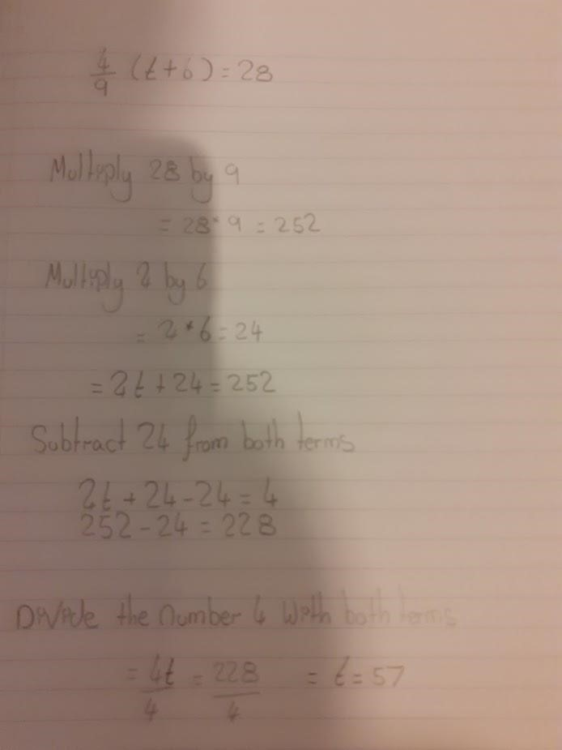

You must deal with an equation as

one item, as you need to make sure

you always do the same thing to

BOTH sides. If you split it up into

separate sides, there is a danger

that you will forget to treat the sides

the same. Think of it like a pair of

scales. You can't just decide to cut

the scales in half and do things to

each side separately. You must

keep the scales as one item and

keep them balanced.



This is correct, but could

be better communicated.

See Comment 2



(

b) Blank Page for

Comments.

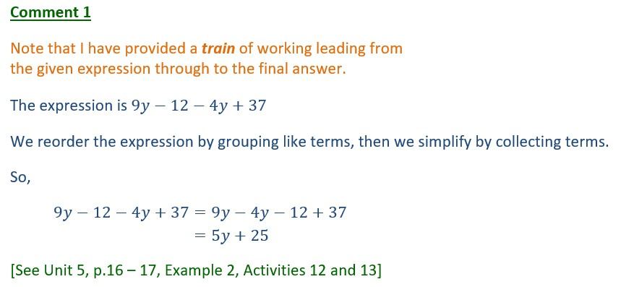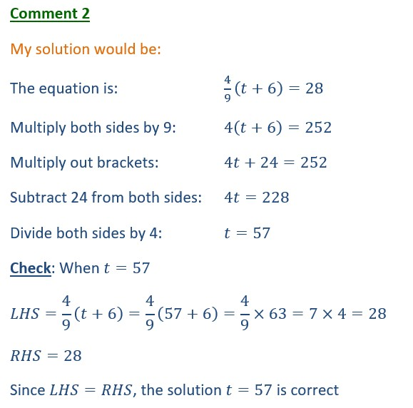

(c)



(1)

(2)

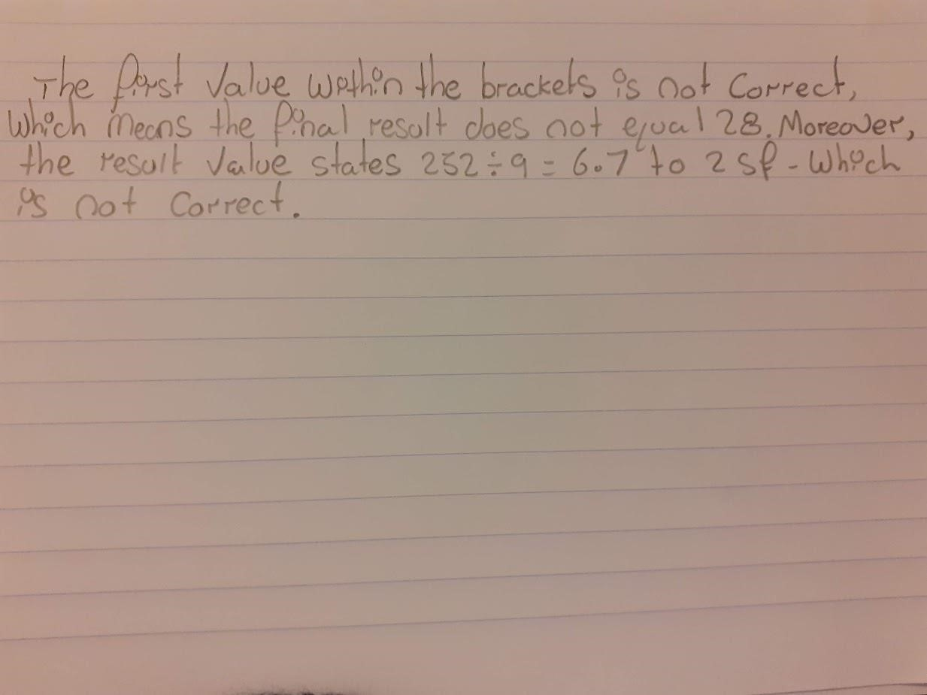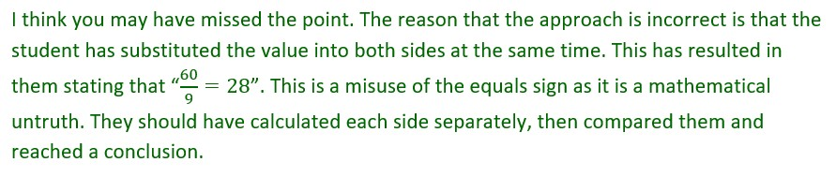

See Unit 5, p.42, Example 19 and Activity 37



|  |  |
| --- | --- |
|  |  |
| You have substituted into both sides of the equation at the same time, which is incorrect. At best, if the solution is correct, you end up with "28 = 28", which is rather silly (a tautology). At worst, if the solution is not correct, you end up with a false statement like " 1 = 2".  Note that you were supposed to check the student's result, not yours. |

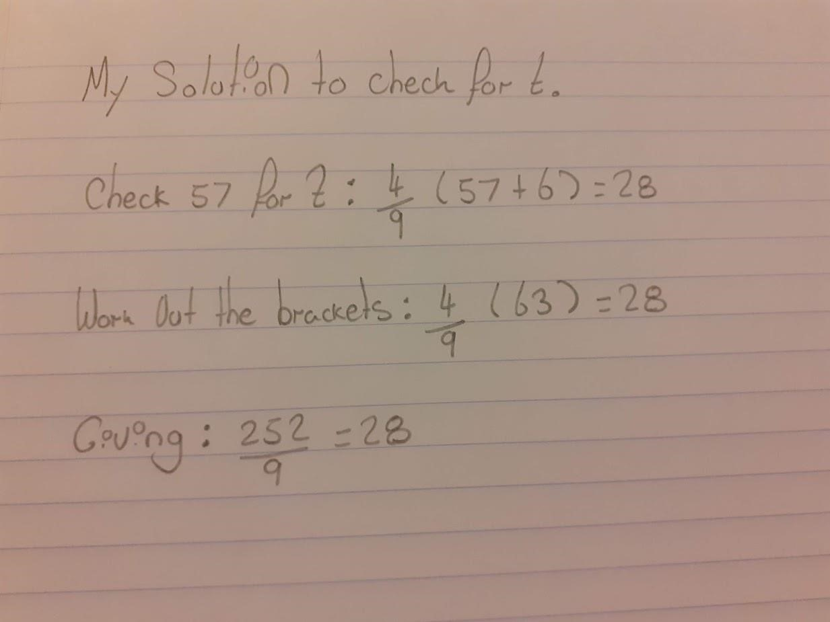

(c) Blank Page for Comments.

Question 4

|  |
| --- |
| In part (a), you are being asked to simplify expressions. You need to start with the given expression and link equal expressions with equals signs, ending with the answer. You need to write a train of working, leading to the answer. I will paste in ideal solutions. |

(a)

(

i)

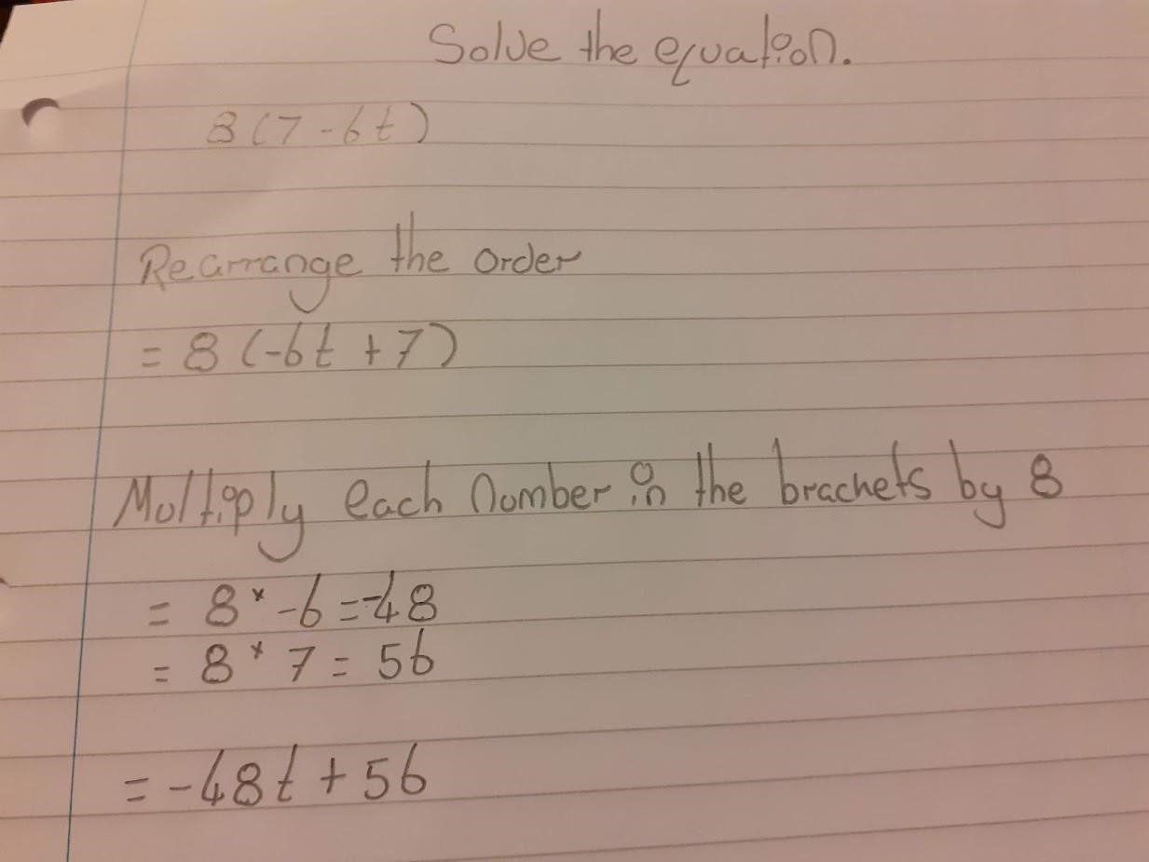

No. You are not

being asked to solve

equations in part (a).

You are being asked

to simplify

expressions.

You have said that all of these things are

equal to each other. But they are not.

Ideal solution:

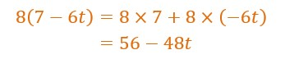

(a) (i) Blank Page for Comments. (ii)

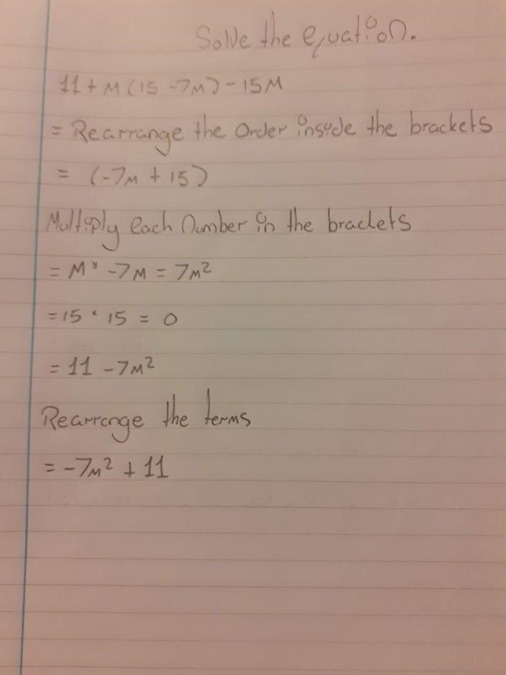

Ideal solution:

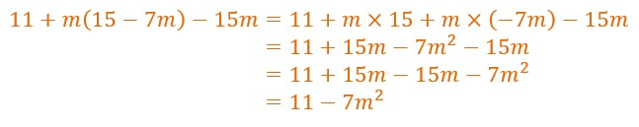

But 15 x 15 is not

equal to 0. I'm not

sure what you mean.

(-1

mark for this

)



1. Blank Page for Comments.

(iii)

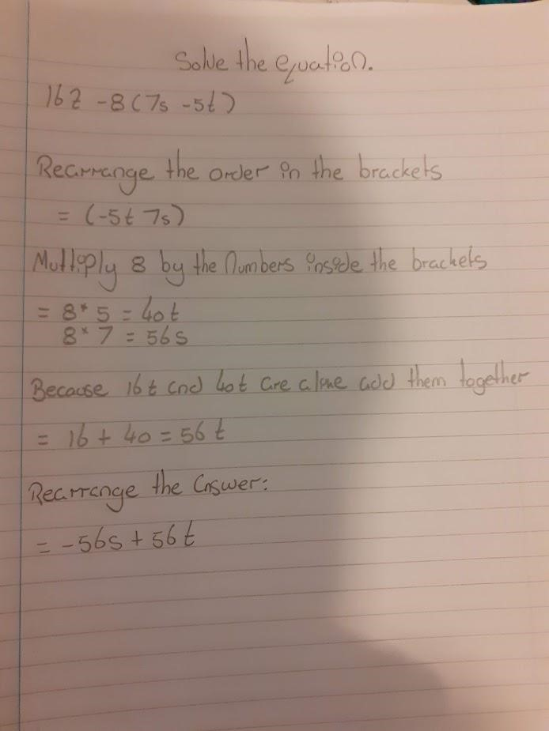

There are no terms in t on the left-hand

side of this working, but t makes an

appearance on the right-hand side. So,

these expressions cannot be equal.



A well-written solution:

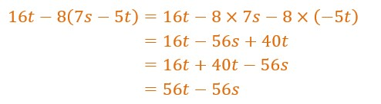

1. Blank Page for Comments.



(

iv)

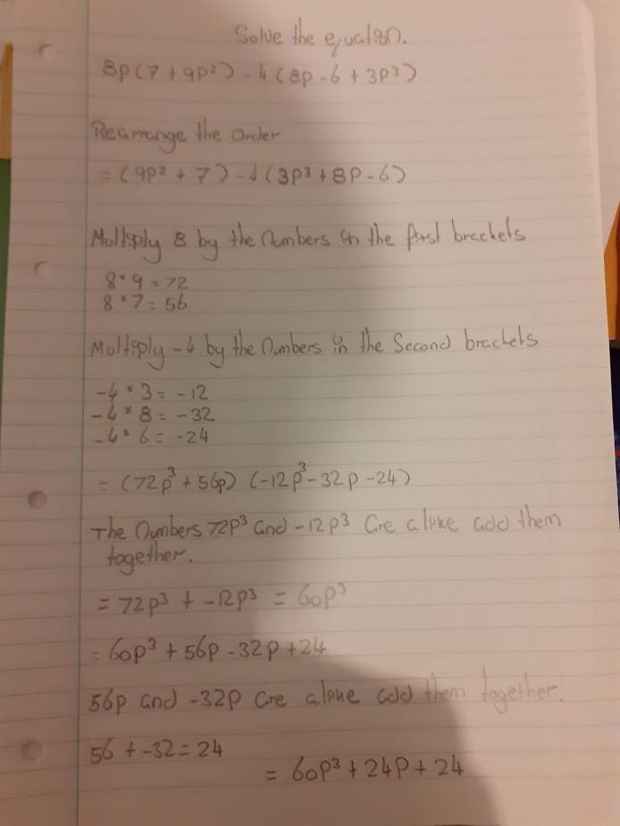

1. Blank Page for Comments.

An ideal solution:

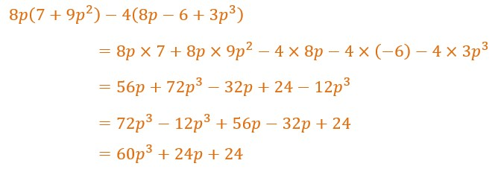

(

v)

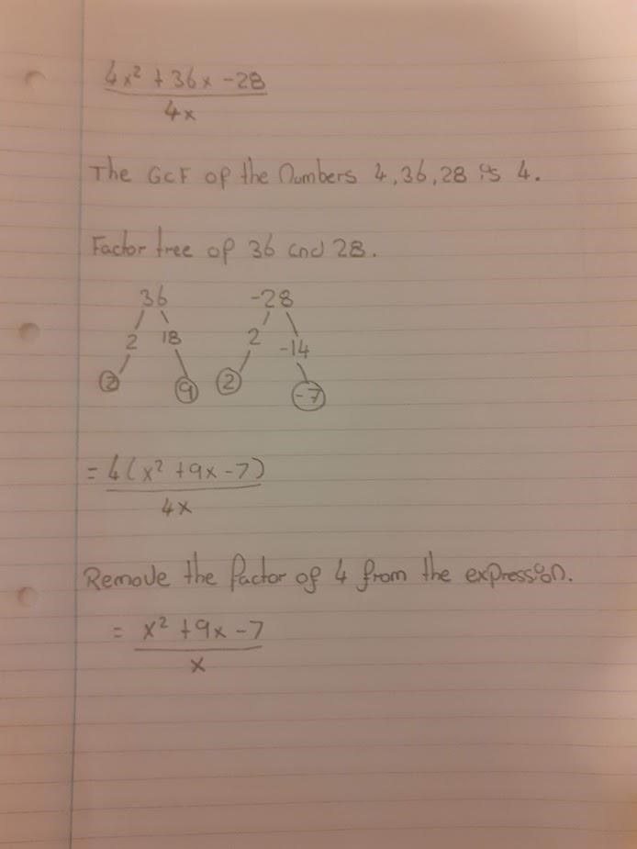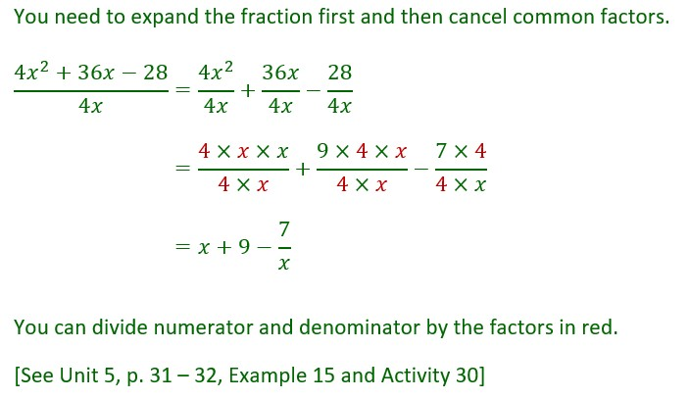

1. Blank Page for Comments.

|  |
| --- |
| In part (b), you ARE given equations to solve. Note the equals sign in the equations in this part. There were no equals signs in the expressions you were given in part (a) |

(a)

(

b

)

(i)

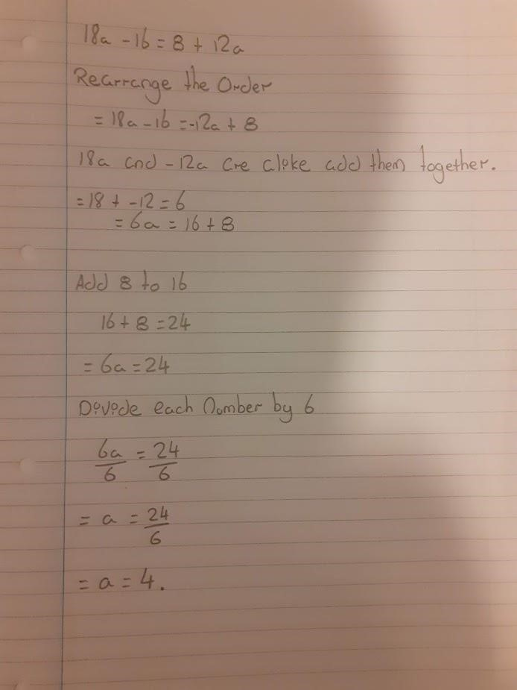

You must not start

an equation with an

equals sign

Do not split the equation

up. Keep it as a whole

equation and make sure

you do the same thing to

both sides to keep it

balanced.



O.K. so far. Now you need to include

a check, in the correct format.

(-1

)

mark

See p. 42, Unit 5

See next page for ideal

solution, with check in

correct format.



(b) (i) Blank Page for Comments.

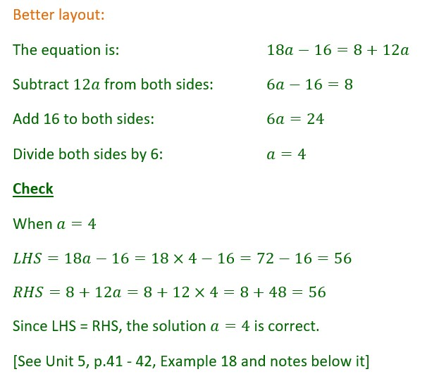

(b)

(

ii)

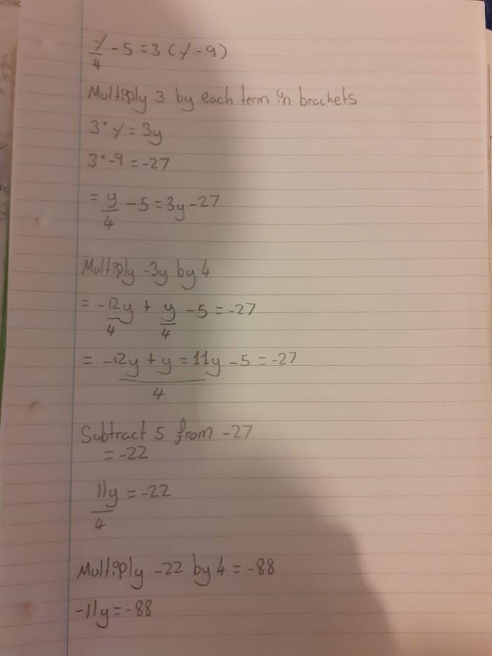

(ii)

Cont’

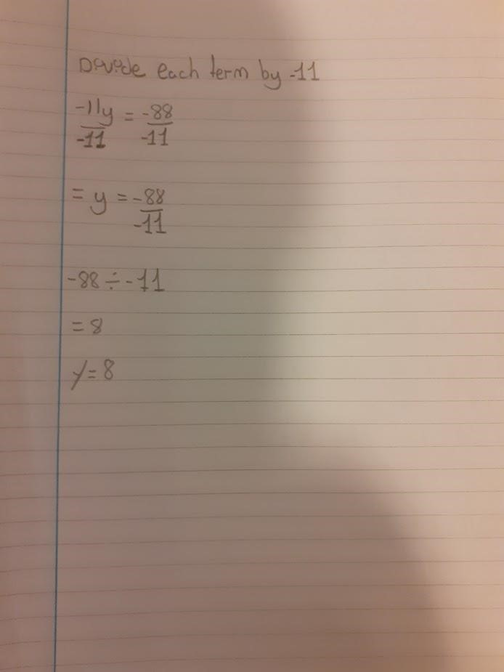

-1

mark for no check

See next page for better layout

and check



(ii) Blank Page for Comments.

